

Bahria University, Islamabad

|  |  |
| --- | --- |
| Kabis Jamil  **Name** | Fahad Ahmed |
| Shaban Ahmed | Abdullah Khan |

**Enrollment No**

01-134251-028 01-134251-019

01-134251-007

01-134251-079

**Subject** Applied Physics Lab

Contents

Introduction: 2

Project Methodology 2

Component Selection and Connection 3

Circuit Design 4

Testing and Validation: 5

Conclusion: 5

Summary of the Project Outcomes 5

Challenges Faced 6

Potential Future Enhancements 6

**Automatic Street Light System**

# Introduction:

Street lighting plays a vital role in ensuring safety and visibility at night. Traditional street light systems, however, often lead to energy wastage because they are manually controlled, leading to lights being on during the day or turning off too late. This project aims to design an automatic street light system using basic electronic components. The primary objective is to automate the street light control based on environmental light levels, ensuring that lights turn on when it gets dark and off when daylight returns. The project focuses on improving energy efficiency by using a Light Dependent Resistor (LDR), BC547 transistor, resistors, and LED to create a cost-effective and energy- efficient automatic street lighting system.

# Project Methodology:

The methodology of this project revolves around utilizing simple electronic components and designing a functional circuit to automate the operation of street lights based on

ambient light levels.

## Component Selection and Connection

The system includes the following components:

* 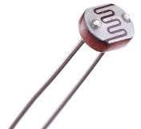**LDR (Light Dependent Resistor)**: An **LDR** is a resistor whose resistance changes based on the intensity of light falling on it. In bright light, the resistance is low, and in darkness, the resistance

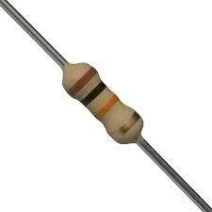increases. It detects ambient light and provides the voltage needed to control the transistor in the circuit.

* **Resistors**: Resistors are used to limit the flow of current through a circuit, ensuring that components like the transistor and LED are not damaged by excessive current. In this project, resistors are

used in series with the LDR and LED to regulate current and protect the components.

* 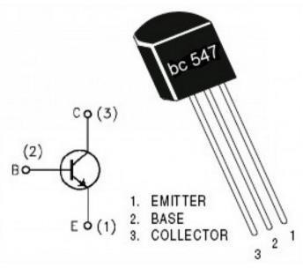**BC547 Transistor**: The **BC547** is a **NPN transistor** that acts as a switch in the circuit. It controls the flow of current to the LED. When the base voltage is high (due to low light), the transistor

switches on, allowing current to flow through the LED and turn it on.

*Figure 1: LDR*

*Figure 2: Resistor*

*Figure 3: Transistor*

* 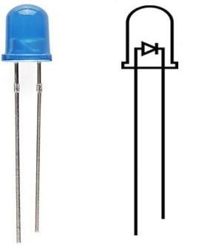**LED (Light Emitting Diode)**: An LED is a diode that emits light when current passes through it. It serves as the streetlight in the circuit. The LED is controlled by the BC547 transistor. When the transistor is on, current flows through the LED, turning it on; otherwise, it remains off.



*Figure 4: LED*

* **Power Supply**: The **power supply** provides the necessary voltage for the circuit. A 9V battery or adapter powers the LDR, transistor, and LED. Without a power supply, the circuit would not operate, as

the components require a steady flow of electrical energy to function properly.

## Circuit Design

*Figure 5: Battery*

The LDR is placed in a voltage divider arrangement with a fixed resistor, which controls the voltage at the junction. This voltage is used to trigger the BC547 transistor, which in turn controls the LED’s operation. The LED will be lit when the transistor is turned on (in low light conditions) and remain off when the light levels are high (during the day).

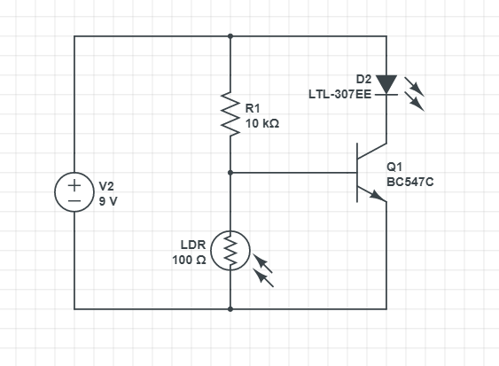***Circuit Diagram:***

***Picture of Circuit:***

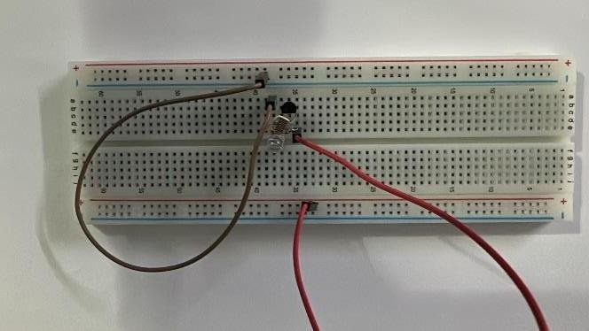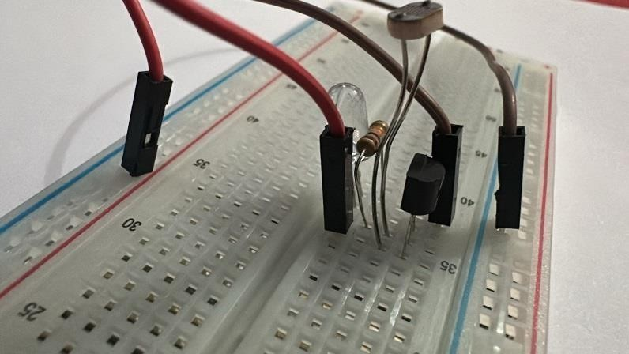

# Testing and Validation:

The automatic street light system was tested in different lighting conditions to ensure it performs as expected:

1. **Daylight Test**: The LDR's resistance was low during daylight, keeping the transistor off and preventing the LED from lighting up.
2. **Low Light Test**: In the absence of light, the LDR's resistance was high, which triggered the transistor and caused the LED to light up.
3. **Current Limiting**: Resistors in series with the LED ensured that the LED was not damaged due to excessive current flow.

The system was validated by monitoring its response to changing light levels. The system successfully turned the street light on and off based on light intensity, ensuring its proper functionality and energy efficiency. The power supply was also tested to confirm the appropriate voltage was provided to each component, ensuring the circuit functioned correctly.

# Conclusion:

## Summary of the Project Outcomes

The project successfully designed and implemented an automatic street light system that efficiently controls street lights based on ambient light levels. The system operates effectively by using simple electronic components such as LDR, transistor, resistors, and LED. The lights turn on automatically when it gets dark and turn off when daylight returns, providing a significant reduction in energy wastage.

## Challenges Faced

The primary challenge was calibrating the LDR to ensure it responded correctly to varying light conditions. Fine-tuning the resistors to control the current and voltage effectively required careful adjustment to prevent overloading sensitive components.

## Potential Future Enhancements

1. **Integration with Solar Power**: The system can be further improved by incorporating solar panels to make it more energy-efficient and environmentally friendly.
2. **Smart Control Features**: Adding smart features, such as remote control or sensor-based adjustments, could enhance the system's adaptability and efficiency.
3. **Extended Range**: Increasing the range and sensitivity of the LDR could improve the system's ability to detect changes in light levels more accurately.

Linkedin: https://www.linkedin.com/in/shaban-ahmad-a87b112ba/

Github: https://github.com/myUserzEveryWhere/AP-project